

**International Islamic University Chittagong**

**Department of Computer Science & Engineering**

**Project Report**

|  |  |
| --- | --- |
| **Course Code** | **:**  CSE--3532 |
| **Course Title** | **:** Tools and Technologies for Internet Programming |
| **Section** | **: 5DF** |
| **Semester** | **:** 5th |
| **Group No.** | **: 02** |

**Project Title**

**FLOWER SHOP MANAGEMENT SYSTEM**

**Submitted By:**

ID : C231515R (Tasriva Sultana)

ID : C231520 (Taslima Tahrin)

ID : C231522(Mahar Afroz)

Submitted To:

Sara Karim

Adjunct Lecturer,Dept. of CSE, IIUC

**TABLE OF CONTENT**

TOPIC PAGE

1. Introduction 01

2. Project overview 01

3. Objectives 02

4. Tools Flowchart 02

5. project ss design 03-05

6. Conclusion 06

6. Flowchart 07

1.INTRODUCTION:

The Flower Shop Management System is a database-driven software application designed to streamline and automate the operations of a flower retail business. In traditional flower shops, managing inventory, customer orders, deliveries, and employee tasks is often done manually, which can lead to inefficiencies, data loss, and customer dissatisfaction. This system aims to digitize and centralize all shop operations, making them more accurate, efficient, and user-friendly. This project focuses on managing core aspects of a flower shop, including inventory management (flowers, bouquets, accessories), customer information, order placement and tracking, supplier interactions, employee roles and sales record.

2PROJECT OVERVIEW:

The Flower Shop Management System is a database application developed to simplify and automate the day-to-day operations of a flower shop. This project focuses on efficiently handling customer orders, managing flower inventory, tracking sales, coordinating deliveries, and maintaining employee and supplier records Key components of the system include:

• Customer Management

• Order Processing

• Supplier Management

• Blog and Review

3. OBJECTIVES:

• To manage customer information effectively, including personal details and purchase history, for better service and marketing.

• To track flower inventory in real-time, including types, quantities, and expiry dates, to avoid overstocking or stockouts.

• To simplify order placement and processing, enabling fast and accurate order tracking from confirmation to delivery.

• To automate billing and payment processes, generating accurate invoices and tracking customer payments.

• To manage supplier and purchase records, ensuring timely procurement of flowers and supplies based on stock levels.

4.Tools:

**Frontend:**

HTML, CSS, JavaScript.

**Backend:**

Xampp, mysql, phpMyAdmin, database.

5 . project ss design :

Home-

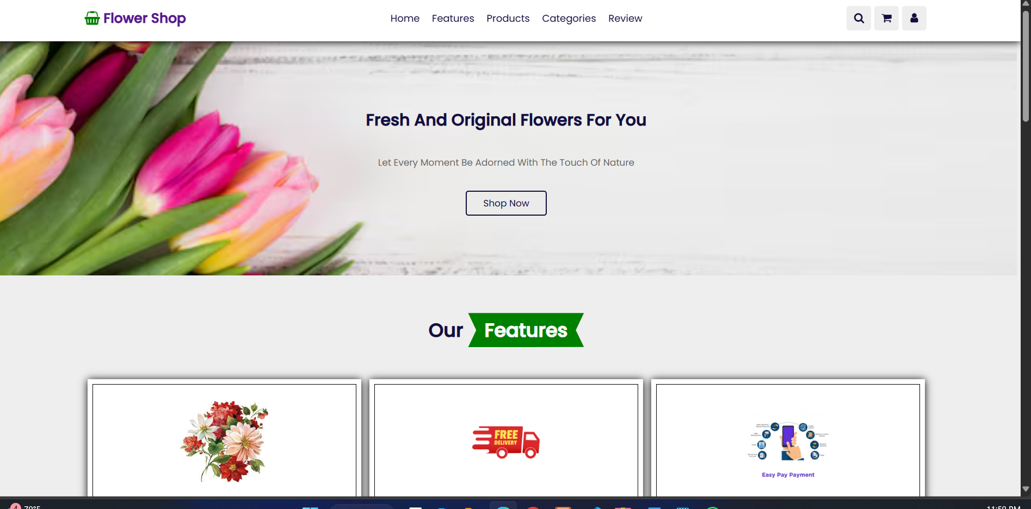

Features-

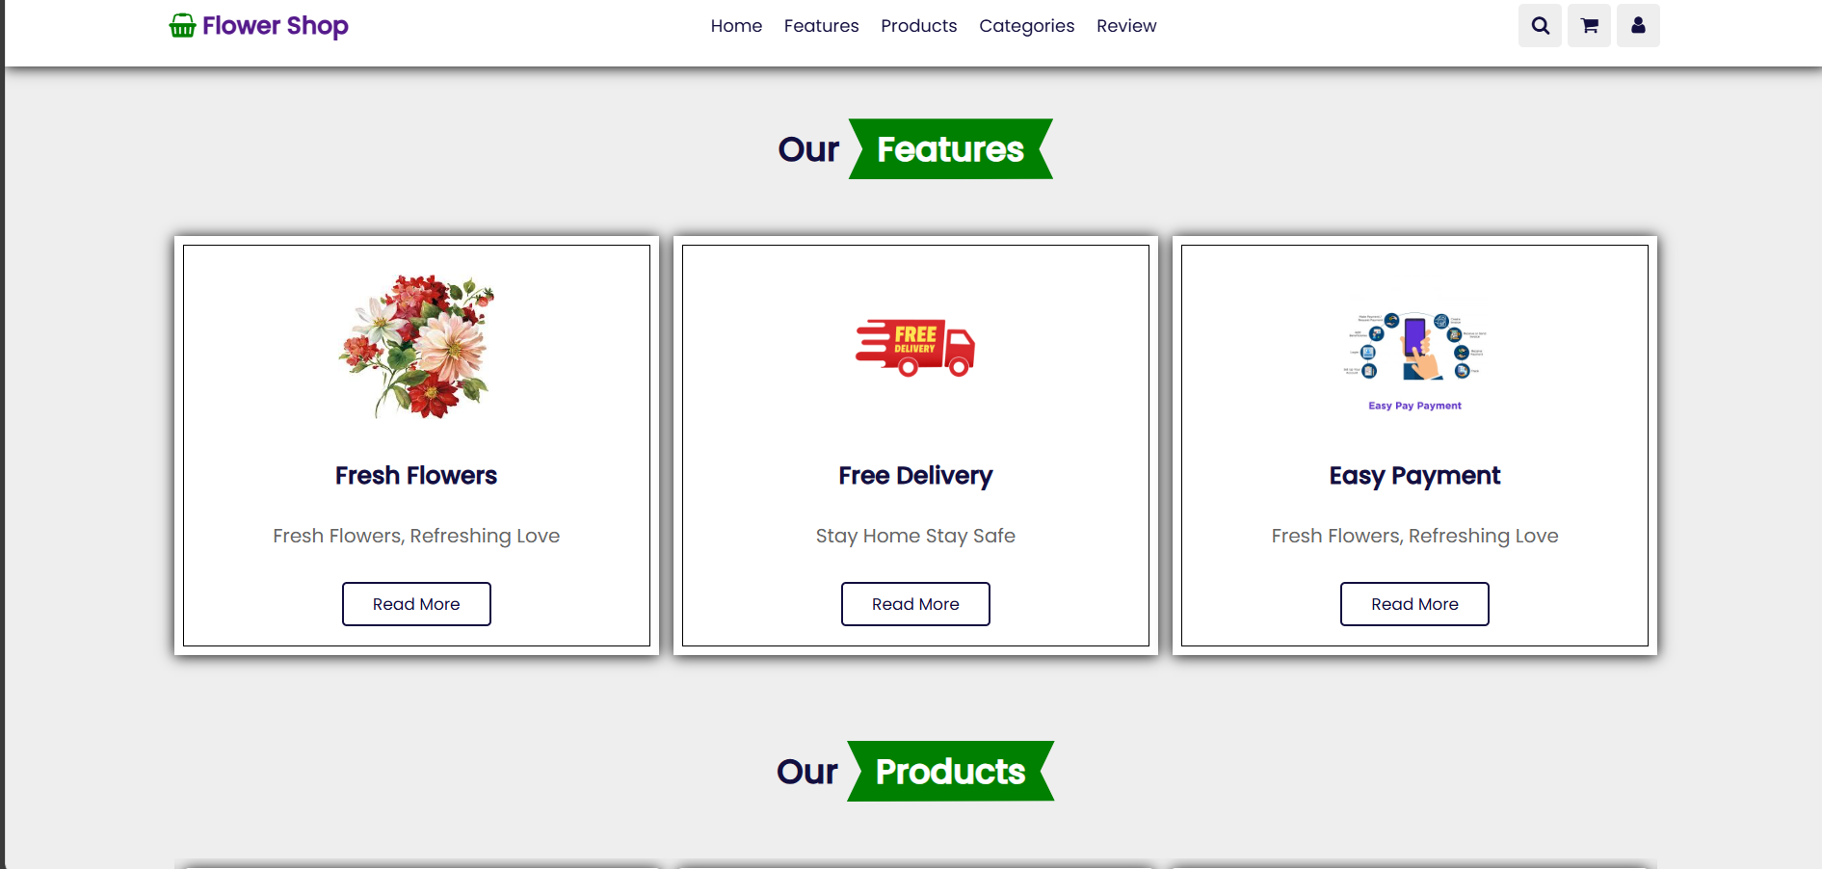

Products-

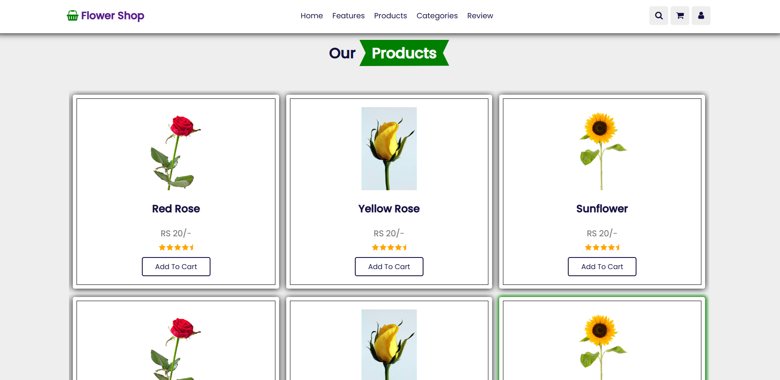

Categories

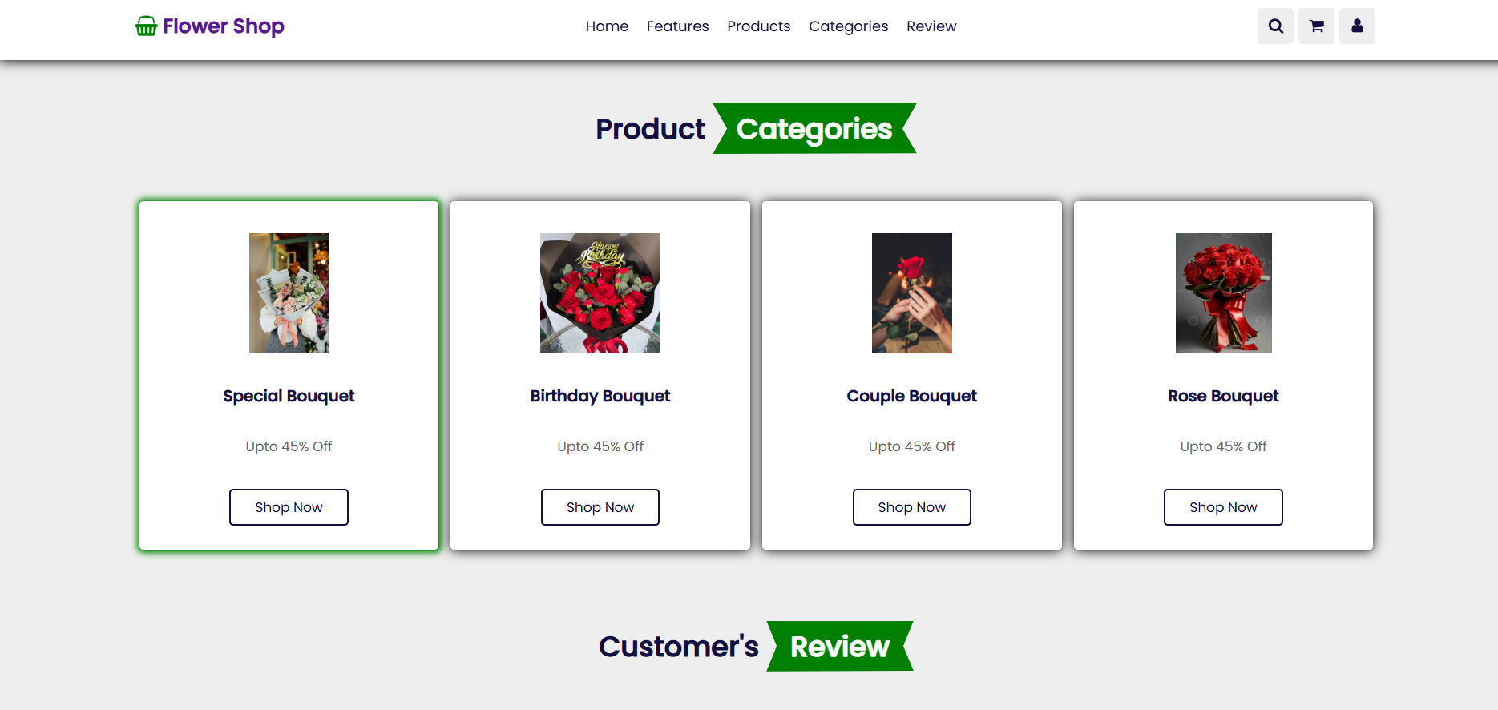

Review

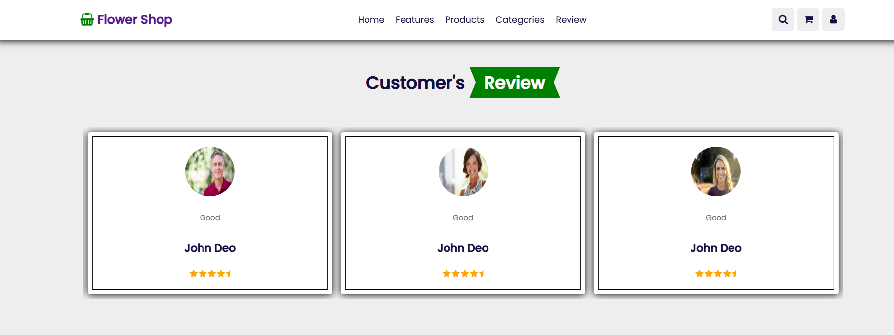

Footer

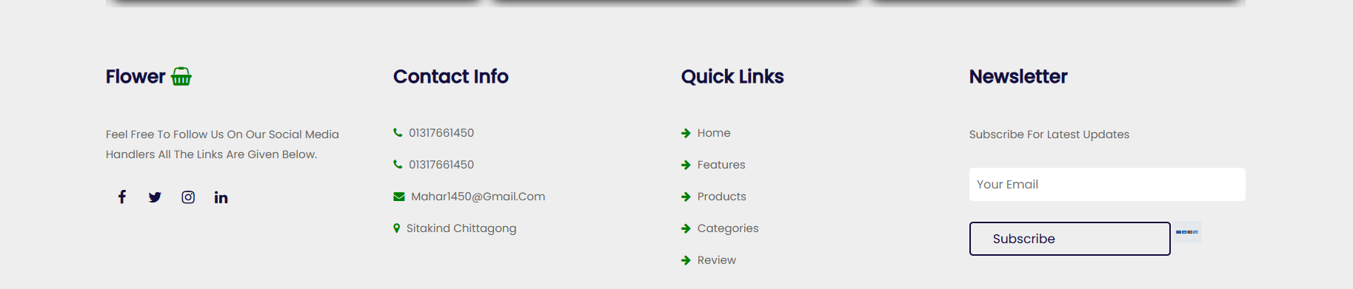

Search bar

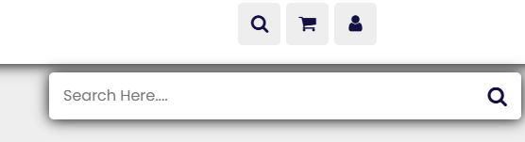

Chart

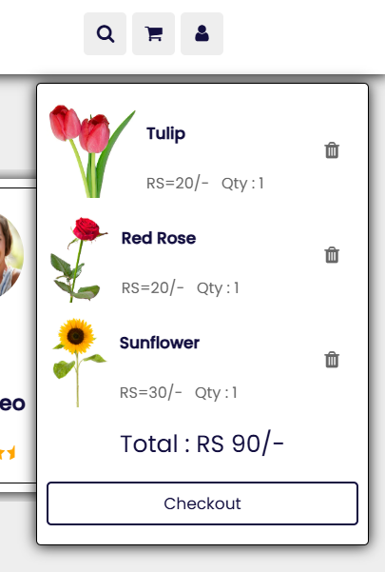

Login

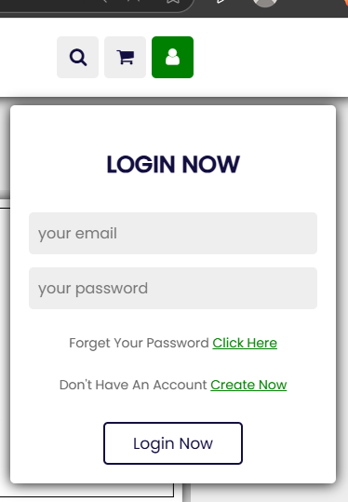

**Conclusion :**

In conclusion, the development of the Flower Shop Website has been a successful attempt to create an interactive, user-friendly, and functional online platform for flower purchasing. The website allows users to easily browse various categories of flowers, view product details, add items to the cart, and place orders conveniently from anywhere. It also provides an admin panel where the shop owner can manage products, view orders, and handle customer data efficiently.

This project has been developed using HTML, CSS, PHP, and MySQL, giving us valuable hands-on experience in full-stack web development. It has helped us enhance our technical skills and understand the workflow of real-life e-commerce applications.

In the future, we plan to improve the website further by adding advanced features such as live chat support, order tracking, mobile responsiveness, and integrated online payment systems to make the user experience even smoother.

**Flowchart:**

Login Form

Shopping Cart

Footer Section

. Special Bouquet

. Birthday Bouquet

. Couple Bouquet

. Rose Bouquet

Review Section

Categories Section

Product Slider 1

. Image

. Name

. Price

. Star ‘Rating

. Add to Cart

Products Section

Home Section(Banner)

. Tagline Description

. “Shop Now” Button

Search Form

Icons(Menue Search , Chart, Login)

Home Section(Banner)

Search From

[Header Section]

.logo(Flower Shop) Home Features, Products , Review

Home